भारतमौसमविज्ञानविभाग |  | India Meteorological Department
Monday, 30th June 2025 (9th Ashadha 1947 Saka)
Summary of observations recorded at 0830 hours IST: The low-pressure area over northwest Bay of Bengal and adjoining West Bengal and Bangladesh coasts lay over coastal Gangetic West Bengal & neighbourhood at 0830 hrs IST of today, the 30th June 2025. The associated cyclonic circulation extended upto 5.8 km above m. s. l. It is likely to move slowly west-northwestwards across north Odisha, Gangetic West Bengal & Jharkhand during next 2 days. The monsoon trough at mean sea level passes through Sri Ganganagar, Delhi, Fatehgarh, Sidhi, Jamshedpur and centre of the low pressure area over coastal Gangetic West Bengal & neighbourhood and thence southeastwards to northeast Bay of Bengal. An east-west trough ran from southwest Uttar Pradesh to the cyclonic circulation associated with the low-pressure area over coastal Gangetic West Bengal & neighbourhood across southeast Uttar Pradesh, Jharkhand, and Gangetic West Bengal and neighbourhood extended between 0.9 to 3.1 km above m. s. l. The cyclonic circulation over central parts of south Uttar Pradesh merged with the above trough. The cyclonic circulation over south Rajasthan & adjoining north Gujarat persisted at 3.1 km above m. s. l. The east-west trough from the upper air cyclonic circulation over south Rajasthan & adjoining north Gujarat to the cyclonic circulation associated with the low pressure area over northwest Bay of Bengal and adjoining West Bengal and Bangladesh coasts became less marked. The upper air cyclonic circulation over north Haryana & neighbourhood became less marked. The upper air cyclonic circulation over central parts of north Arabian Sea became less marked.
Day temperatures were markedly above normal (> 5.1°C) at isolated places over Sub Himalayan West Bengal & Sikkim. appreciably above normal (3.1°C to 5.0°C) at few places over Arunachal Pradesh, Assam & Meghalaya and Jammu-Kashmir-Ladakh-Gilgit-Baltistan-Muzaffarabad; at isolated places over Tamil Nadu, Puducherry & Karaikal. above normal (1.6°C to 3.0°C) at few places over Bihar, coastal Karnataka and Lakshadweep; at isolated places over Odisha, Himachal Pradesh, Saurashtra & Kutch, Konkan & Goa, Telangana, Rayalaseema and Kerala & Mahe. near normal (-1.5°C to 1.5°C) at many places over Gangetic West Bengal and Madhya Maharashtra; at most places over Nagaland, Manipur, Mizoram & Tripura and south interior Karnataka; at few places over Andaman & Nicobar Islands, east Uttar Pradesh, west Rajasthan, Marathwada, coastal Andhra Pradesh & Yanam and north interior Karnataka; at isolated places over west Uttar Pradesh, Uttarakhand, east Rajasthan and Chhattisgarh. The highest maximum temperature of 40.8°C was reported at Pathankot (Punjab), and Bikaner (Rajasthan).
.
Preliminary Earthquake Report: 1) An earthquake shock of Moderate intensity at its origin with epicenter at Lat. 30.25° North and Long. 69.82° East, 419 km NW of Bikaner, Rajasthan; India; Pakistan; about 1737 kms away from Pune, was recorded by the seismographs in the CR & S Office, Pune at 03 Hrs. 55 Min. 34 Secs. IST on 29-06-2025 having its magnitude 5.2 on the Richter scale. 2) An earthquake shock of Slight intensity at its origin with epicenter at Lat. 29.35° North and Long. 81.94° East, 168 km E of Pithoragarh; India; Nepal; about 1786 kms away from Pune, was recorded by the seismographs in the CR & S Office, Pune at 14 Hrs. 20 Min. 50 Secs. IST on 29-06-2025 having its magnitude 4.2 on the Richter scale.
The Southwest Monsoon has been Vigorous over west Uttar Pradesh, Himachal Pradesh and active over Jharkhand, Uttarakhand, Haryana, west Madhya Pradesh and Telangana. It has been subdued over Marathwada and south interior Karnataka.
Total 318 Station reported rainfall today. Total rainfall is 340.7cm. Total 305 Station reported rainfall today whose normals are available. Total rainfall is 315.4cm with normal station total is 293.5cm.
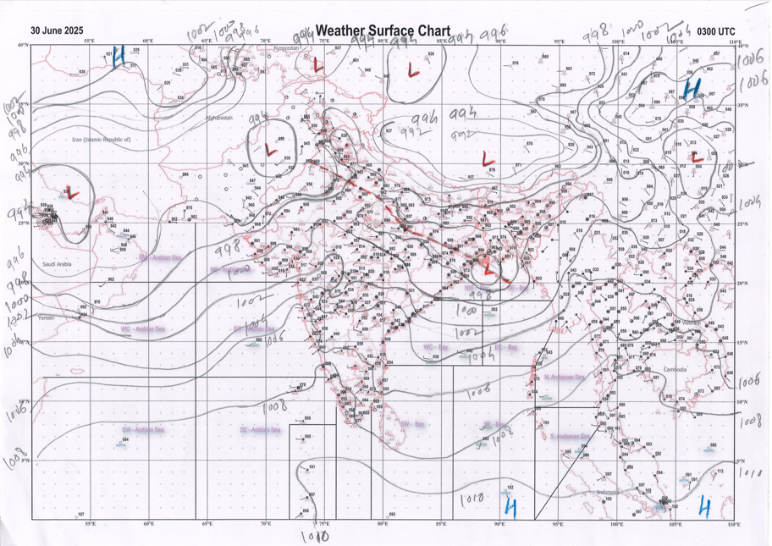 | 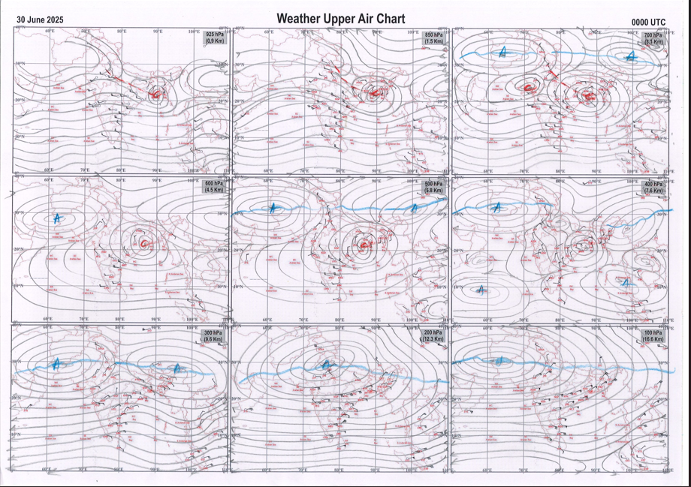
g.1. Analysed surface chart based on 03z observation | Fig.2. Analysed upper air chart based on 00z observation

Dr. S D Sanap.
Scientist ‘D’
CR & S Office, Pune  Issued at 1245 hrs. IST |  | Weather Forecasting Division  CR&S, Pune

Indian regions | Realised rainfall (chief amount in cm during past 24 hrs):
East | most places: Gangetic West Bengal+ and Jharkhand+++  many places: Sub-Himalayan West Bengal & Sikkim and Odisha+++  a few places: Arunachal Pradesh, Assam & Meghalaya+, Nagaland-Manipur-Mizoram-Tripura+ and Bihar++  Boram 14.3, Jamda 13.2, Patamda 11.8, Maharajganj 11.6, Sarasakana 11.0, Lengpui 9.9, Purihansa 9.7, Burnpur 9.0, Jowai 6.9, Nabinagar 6.8, Fagu tea estate 6.4, Mawsynram 5.8, Mawkyrwat 5.6, Daparijo 5.0, Jamshedpur 4.8, Asansol (CWC) 4.5, Chalouni tea estate 3.9, Daporizo AWS & Malkangiri 3.8 each, Seppa AWS 3.3, Aizwal 3.1, Jalpaiguri 2.7, Kadamtala ARG 2.1, Patna aerodrome 1.5.
North | most places: west Uttar Pradesh+++, Uttarakhand+++ and Himachal Pradesh+++  many places: Haryana+ and Punjab  a few places: east Uttar Pradesh+ and Rajasthan+  isolated places: Jammu-Kashmir and Ladakh  Mawana 17.8, Deoprayag 17.3, Jalesar 16.6, Pandoh 12.3, Meerut 12.0, Mandi 11.9, Barkot 11.1, Uska bazar fmo 10.1, Fatehgarh 9.4, Churu 8.5, Palampur & Churu tehsil SR 8.3 each, Pungal SR 8.2, Jagadhari 7.9, Kumher SR 7.3, Uttar kashi 7.2, Chandigarh 7.1, Malakhera SR 6.6, Radaur 6.5, Kanpur 6.4, Bakore ARG 5.5, Rs pura ARG 5.1, Ranjit sagar dam site 5.0, Bhatinda AMFU & Jammu AP 4.3 each, Sikar 2.0, Ludhiana 1.4.
Central | most places: Vidarbha+  many places: west Madhya Pradesh+++ and Chhattisgarh+  a few places: east Madhya Pradesh+  Pathari 17.6, Badoda 12.3, Gaurihar 11.1, Arjunda 10.8, Gangalur 10.0, Lalburra 8.9, Chamorshi 8.1, Gwalior 7.6, Mul 7.0, Tikamgarh-aws 5.6, Rajnandgaon 4.6, Gondia 2.6.
Peninsula | most places: Konkan & Goa and coastal Karnataka  many places: Gujarat Region+, Madhya Maharashtra, coastal Andhra Pradesh and Telangana  a few places: Saurashtra & Kutch and Kerala  isolated places: Marathwada, Rayalaseema, Tamil Nadu and interior Karnataka  Kadi 9.1, Viramgam 8.4, Mahabaleshwar 6.0, Julurpad & Castle rock 5.9 each, Huzurabad 5.8, Savarde-arg 5.7, Sangameshwar devrukh & Shahuwadi 5.5 each, Khammam urban 3.9, Mudubidre & Londa 3.6 each, Sindkheda & Eluru 3.5 each, Paleru bridge & Agumbe emo 3.1 each, Aralam AWS 2.7, Diu & Kinwat 2.6 each, Dasada & Mangaluru AP 2.5 each, V.vidyanagar SR, Khanapur & Mahe 2.2 each, Dabolim n.a.s. navy 2.1, Ranavav & Sringeri HMS 1.8 each, Kalasa 1.5, Manthralayam 1.4, Nandikotkur & Kannur 1.2 each, Mahur 1.1, Nandigama & Nandyal 0.9 each, Worth estate cher 0.8, Kalaburgi 0.6, Chinnakalar 0.2.
Islands | most places: Andaman & Nicobar+  a few places: Lakshadweep  Port blair 6.8, Long island 5.5, Hut bay 4.3, Amini 0.3, Agathi 0.1.
Table 2. Forecast / warnings (distribution of rain / thundershowers) for 7 days (valid from time of origin upto 0830 hrs IST of next day)
Sr N. |  | Sub-division Name | Day 1 | Day 2 | Day 3 | Day 4 | Day 5 | Day 6 | Day 7 | Sr. No. | Sub-division Name | Day 1 | Day 2 | Day 3 | Day 4 | Day 5 | Day 6 | Day 7
 |  |  | 30 Jun | 01 July | 02 July | 03 July | 04 July | 05 July | 06 July |  |  | 30 Jun | 01 July | 02 July | 03 July | 04 July | 05 July | 06 July
 | 1 | Andaman Nicobar Islands | W  | W  | W  | W | W | W | F | 19 | west Madhya Pradesh | W ++  | W++  | W +  | W +  | W ++  | W ++ | W ++ 
 | 2 | Arunachal Pradesh | F +  | F +  | W ++  | W ++  | F +  | F + | F +  | 20 | east Madhya Pradesh | W ++  | W ++  | W +  | W ++  | W ++  | W + | W ++ 
 | 3 | Assam-Meghalaya | F +  | F +  | F +  | F +  | F +  | F + | W +  | 21 | Gujarat region | W ++  | W+  | W++  | W++  | W +  | W ++ | W + 
 | 4 | Nagaland-Manipur-Mizoram-Tripura | F +  | F +  | F ++  | F ++  | F +  | W + | W +  | 22 | Saurashtra and Kutch | W +  | W +  | W + | W + | W + | W + | W + 
 | 5 | Sub Himalayan West Bengal/Sikkim | W +  | W +  | W +  | F + | F + | W + | W + | 23 | Konkan and Goa | W +  | W +  | W++  | W ++  | W +  | W ++ | W + 
 | 6 | Gangetic West Bengal | W ++ | W +  | F  | W  | W +  | W + | W +  | 24 | Madhya Maharashtra | S +  | F +  | F++ | S ++ | S | F ++ | F
 | 7 | Odisha | W ++  | F ++  | F ++  | F ++  | F + | F | F + | 25 | Marathwada | S  | F  | S  | I | I  | S  | S 
 | 8 | Jharkhand | W ++  | W +  | F +  | F +  | W +  | W + | W +  | 26 | Vidarbha | W +  | W +  | F  | F  | W ++  | W + | W ++ 
 | 9 | Bihar | F ++  | F ++  | F ++  | F+  | F+  | S  | S +  | 27 | Chhattisgarh | W ++  | W ++  | W +  | W ++  | W ++  | W + | W ++ 
 | 10 | east Uttar Pradesh | F +  | F +  | F +  | F +  | F +  | F +  | S +  | 28 | Coastal Andhra Pradesh and Yanam | F +  | S  | S  | S  | S  | S | S 
 | 11 | west Uttar Pradesh | W ++  | F ++  | F +  | F +  | F +  | F +  | F +  | 29 | Telangana | F +  | S  | S  | S  | S  | S | S 
 | 12 | Uttarakhand | W ++  | W ++  | F +  | F +  | F +  | F +  | F +  | 30 | Rayalaseema | I + | I + | I + | I | I | I | I
 | 13 | Haryana,Chandigarh and Delhi | W ++  | F +  | F + | F | F | F + | F | 31 | Tamil Nadu, Puducherry and Karaikal | I + | I + | I + | I  | I  | I | I 
 | 14 | Punjab | F ++  | F +  | F + | F + | F | F + | F | 32 | Coastal Karnataka | W +  | W  | W + | W +  | W +  | W + | W +
 | 15 | Himachal Pradesh | W ++  | F +  | W +  | W + | F + | W + | W + | 33 | North interior Karnataka | F | F | F | F + | S + | F + | F +
 | 16 | Jammu-Kashmir and Ladakh | S  | S  | S  | S  | S  | S  | S  | 34 | South interior Karnataka | S | S | S | F + | F + | S + | S +
 | 17 | west Rajasthan | I  | I  | I  | I +  | S +  | S +  | S +  | 35 | Kerala and Mahe | F | F | F + | F + | F + | F | F +
 | 18 | east Rajasthan | S +  | F +  | F +  | F +  | F +  | F++  | F+  | 36 | Lakshadweep | F  | F | F | F | F | F | F
Legends: D = Dry I = Isolated S = Scattered F = Fairly widespread W = Widespread #= heavy to very heavy rain at a few places with extremely heavy rain at isolated places +++= heavy rain at a few places with very heavy rain at Isolated places ++= heavy to very heavy rainfall @=Isolated exceptionally heavy rainfall + = heavy rain ●/*= rain or snow ♦ = very light rain ≡=fog= thunderstorm with lightning =Squall / Gusty / gale / strong wind ­ =cold wave/cold day += heat wave/warm night/hot and humid weathe r=Duststorm =ground frost = Hail

Fig. 4: Districtwise warnings for five days for Maharashtra State
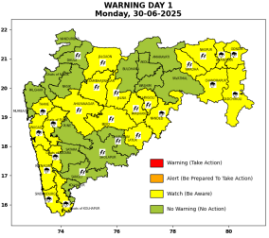 | 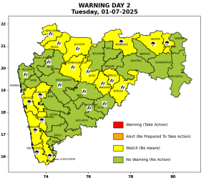 | 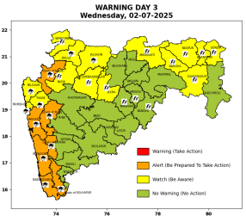 | 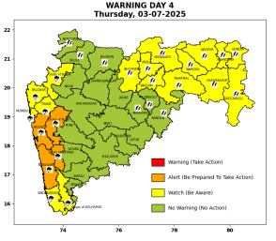 | 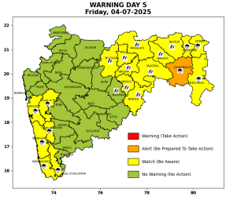

Pune, Lohegaon and Pashan observations at 0830 hrs. IST of Today
 | Temperature (°C) |  |  |  |  | Humidity (%) |  |  |  | Rainfall (mm)
 | Max.  past  24 hrs | Dep.  from  normal | Min.  past  24 hrs. | Dep.  from  normal | Dry  Bulb | At 0830 hrs. IST | Dep.  From  normal | At 1730  hrs. IST of y’day | Dep.  from  normal | Past  24 hrs. | Since  1st June | Dep.  from  normal
PNE | 28.5 | -1.2 | 22.4 | -0.3 | 24.0 | 92 | 10 | 80 | 5 | 2.0 | 267.5 | 114.6
PSN | 27.8 | - | 21.3 | - | 23.4 | 98 | - | 82 | - | 3.4 | 309.4 | -
LHG | 30.5 | -0.5 | 24.4 | 3.4 | 25.7 | 82 | 0 | 65 | -3 | 0.8 | 249.2 | 147.8

 |  |  |  |  |  |  | Local (Pune and neighbourhood) forecast
Max./Min. Temperature (°C) |  |  |  |  |  |  |  |  | Weather
Date | Pune | Pashan | Lohegaon | Chinchwad | Lavale | Magarpatta | NDA | Koregoan Park
30/06/25 | 30 / 22.4* | 28 / 21.3* | 31 / 24.4* | 28 / 22.6* | 27 / 22.0* | 29 / 24.4* | 27 / 22.9* | 29 / 22.9* | Generally cloudy sky. Light rain very likely. (Heavy rainfall at isolated places in ghat areas)
01/07/25 | 29 / 22 | 27 / 21 | 30 / 24 | 28 / 22 | 27 / 22 | 28 / 24 | 28 / 23 | 29 / 23 | Generally cloudy sky. Light to moderate rain very likely. (Heavy rainfall at isolated places in ghat areas)
02/07/25 | 29 / 21 | 27 / 20 | 30 / 23 | 28 / 21 | 27 / 21 | 28 / 23 | 28 / 22 | 29 / 22 | Generally cloudy sky. Light to moderate rain very likely. (Heavy to very heavy rainfall at isolated places in ghat areas)
03/07/25 | 30 / 21 | 28 / 20 | 31 / 23 | 29 / 21 | 28 / 21 | 29 / 23 | 29 / 22 | 30 / 22 | Generally cloudy sky. Light to moderate rain very likely. (Heavy to very heavy rainfall at isolated places in ghat areas)
04/07/25 | 30 / 22 | 28 / 21 | 31 / 24 | 29 / 22 | 28 / 22 | 29 / 24 | 29 / 23 | 30 / 23 | Generally cloudy sky. Light to moderate rain very likely. (Heavy rainfall at isolated places in ghat areas)
05/07/25 | 29 / 22 | 27 / 21 | 30 / 24 | 28 / 22 | 27 / 22 | 28 / 24 | 28 / 23 | 29 / 23 | Generally cloudy sky. Light to moderate rain likely.
06/07/25 | 29 / 21 | 27 / 20 | 30 / 23 | 28 / 21 | 27 / 21 | 28 / 23 | 28 / 22 | 29 / 22 | Generally cloudy sky. Light to moderate rain likely.
Rainfall Distribution |  |  | Rainfall Categories | Rainfall (mm) |  | Cloud condition |  |  |  | Rainfall Intensity |  | Range
Widespread (W) | 76-100% |  | Very Light rain | Trace to 2.4 mm |  | Mainly clear sky |  | 1-2 oktas |  | Light Spell |  | 1 cm/hr
 |  |  | Light rain | 2.5 to 15.5 mm |  | Partly cloudy sky |  | 3-4 oktas |  | Moderate Spell |  | 1-2 cm/hr
Fairly Widespread (FW) | 51 – 75% |  | Moderate rain | 15.6 to 64.4 mm |  | Generally cloudy sky |  | 5-7 oktas |  | Intense Spell |  | 2-3 cm/hr
Scattered (S) | 26 – 50% |  | Heavy rain | 64.5 to 115.5 mm |  | Overcast |  | 8 oktas |  | Very Intense Spell |  | 3-5 cm/hr
isolated (I) | 1 – 25% |  | Very heavy rain | 115.6 to 204.4 mm |  |  |  |  |  | Extremely Intense Spell |  | 5-10 cm/hr
D (D) | No Rain |  | Extremely heavy rain | ≥ 204.5 mm |  |  |  |  |  | Cloudburst |  | > 10 cm/hr
Probability Terms in %: |  |  | Heavy snow | 6.5 to 11.5 cms water equivalent of rain
unlikely | < 25 |  | Very heavy snow | 11.6 to 20.4 cms water equivalent of rain
likely | between 25 50
very likely | between 51 75
most likely | >75
* = realized temperature
Mumbai (Colaba) |  |  |  | Nagpur (AP)
Date 2025 | T max °C | T min °C | Weather | T max °C | T min °C | Weather
30/06 | 30 | 27 | Generally cloudy sky with moderate rain. | 29 | 23 | Generally cloudy sky with a few spells of rain or thundershowers. Thunderstorm accompanied with Hailstorm.
01/07 | 31 | 26 | Generally cloudy sky with moderate rain. | 29 | 23 | Generally cloudy sky with heavy rain. Thunderstorm accompanied with lightning.
02/07 | 30 | 26 | Generally cloudy sky with heavy rainfall. | 28 | 23 | Generally cloudy sky with a few spells of rain or thundershowers. Thunderstorm accompanied with lightning.
03/07 | 30 | 26 | Generally cloudy sky with heavy rainfall. | 29 | 23 | Generally cloudy sky with moderate rain.Thunderstorm accompanied with lightning.
04/07 | 31 | 26 | Generally cloudy sky with moderate rain. | 29 | 23 | Generally cloudy sky with moderate rain.Thunderstorm accompanied with lightning.
05/07 | 31 | 25 | Rain. | 29 | 23 | Rain.
06/07 | 31 | 25 | Rain. | 29 | 23 | Rain.

